Name________________________________ Date______________________
Scientific Method Crossword Puzzle

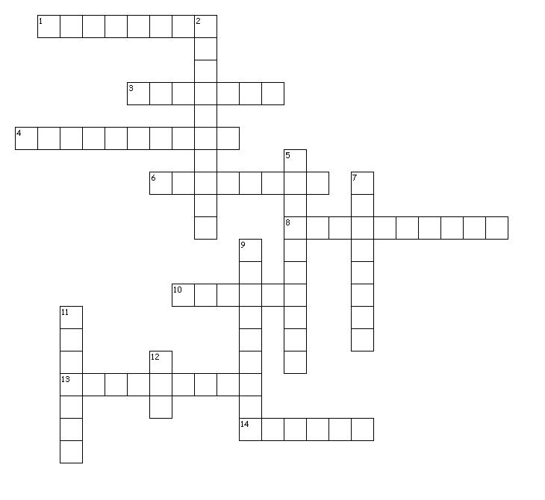

Across

- Anything that can be changed or controlled in an experiment, and/or any changes that occur because of something that did change

- The study of natural phenomena
- An educated guess based on observation
6. The first step of the scientific method is to have one of these
8. Results are based on repeatable observations and/or explanations

10. Scientists use their data to make charts and what to communicate the results of an experiment?
- Theories are subject to revision and correction, even to the point of the entire theory being proven wrong
- Can be used as principles of explanation and prediction for a group of phenomenon

Down
2. After scientists make a hypothesis, they perform what to collect data?
5. Scientists write this after an experiment to summarize it and its results
7. The natural cause of the event must be
- This kind of variable is the part of the experiment that is affected by the independent variable
- Is the part of an experiment that is not being tested and is used for comparison
- At the time that it is made, no exceptions have ever been found to this

