Name: ___________________________ Date: ___________________ Period: ____________

Script Lab Exercise 2

1. Open your text editor.
2. Setup a basic HTML document and include both the heading and the body sections.
3. Set the background color of the document to #000000 and the text color to #ffffff.
4. In the opening body tag, add the onload event handler to call the dealer() function when the page loads.
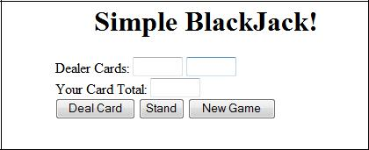
5. Below the opening body tag, add “Simple BlackJack!” as a centered level 1 heading.

You will now create the inside a one-cell table. below very carefully so constructed properly.

6. Open a table tag, set the width of the table to 350 and the background color of the table to #00aa00, and center the table on the screen.
7. Within the cell of the table, open a form tag and name the form cardtable.
8. Add the label “Dealer Cards:” as shown above followed by two text fields. The first text field should be named dealer1 and the second should be named dealer2. Both should be have a size of 5.
9. Add a line break.
10. Next add the label “Your Card Total:” followed by a text field named player with a size of 5.
11. Add a line break.
12. On the next line, you will create three buttons. Each button will call a function that we will define within the heading of the document.

Deal Card Button

13. The button should be named deal but display Deal Card on the button. The button should call the dealCard() function when clicked. (Use the onclick event handler).
Stand Button
14. The button should display Stand and call the stand() function when clicked.
New Game Button.
15. The button should display New Game and call the dealer() function when clicked.
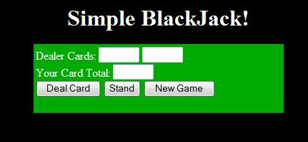
16. Save the file as Lab2.htm and preview it in your browser to make sure everything shows up. Your screen should resemble the example shown here. If not, fix any errors before moving on.

17. Move into the heading section and open a set of script tags.
18. At the top of the script section, declare three variables called player, dealer1, and dealer2, and initialize all to 0.
19. Create the following stub functions within the script section.
Creating the dealer() Function
function dealer()
{
}

function stand()
{
}

function dealCard()

{
}

20. Move into the dealer function and add the following line of code. document.cardtable.deal.disabled=false;

This line of code will make sure that the deal button is enabled.

Random Number Notes (Do not type this information)
Scripts can generate random numbers; the code below will return a random floating point number (number with a decimal point) ranging from 0 to 4. (Use one number higher than you want the random number to be)

var num = Math.randon()*5;

To remove the decimal and convert the number to an integer, use the Math.floor() method.

num = Math.floor(num);

21. Within the dealer() function, use the Math.random() and Math.floor() methods to generate a random integer between 1 and 11 and assign it to the dealer1 variable. NOTE: You will need to add 1 to the number generated because it starts at 0.
22. Generate another random integer between 1 and 11 and assign it to dealer2 variable.
23. Generate a third random integer, this time between 2 and 22, and assign it to the player variable.
24. The function should then place the value of dealer1 into the form field named dealer1.
25. Next, place the text “hidden” into the form field named dealer2.
26. Then place the value of player into the form field named player.
27. Move to the body tag of the document and add the onload event handler to run the dealer() function when the page loads.

Creating the stand() Function

28. Place your cursor between the curly braces of the stand() function.
29. Place the value of the dealer2 variable into the form field named dealer2.
30. Next, add the following line of code to deactivate the deal button: document.cardtable.deal.disabled=true;

Creating the dealCard() Function

31. Move your cursor to inside the curly braces of the dealCard() function.
32. Declare a variable called card and assign it a random integer between 1 and 11.

(look back up at the Random Numbers notes under Creating the dealer() Function section)
33. Increase the value of the player variable by the value of the card variable player = player + card;
34. Place the new value of player into the form field named player.
35. Resave the document and test it in your browser. Check each button to make sure each calls its appropriate functions, and make sure each function operates properly.

