Technology Skill Puzzle

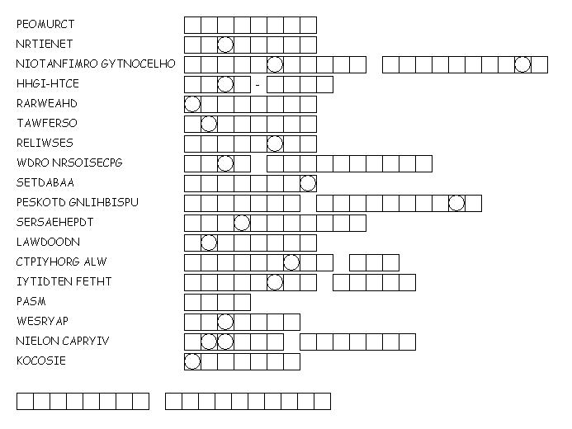

Unscramble each of the clue words.

Take the letters that appear in boxes and unscramble them for the final message.

