Test Your Knowledge - Investigation

You are a radiographer and have been working the night shift at Memorial Hospital. During your shift you have taken x-rays on several different patients that came into the emergency room. Review your vocabulary while looking at the diagrams below, and then determine the type of fracture seen on each x-ray. Write the number of the x-ray next to the diagnosis you choose.

_____________ | 1. | greenstick fracture
_____________ | 2. | dislocated elbow
_____________ | 3. | dislocated shoulder
_____________ | 4. | longitudinal fracture
_____________ | 5. | impacted fracture
_____________ | 6. | depressed fracture
_____________ | 7. | comminuted fracture
_____________ | 8. | spiral fracture
_____________ | 9. | closed fracture
_____________ | 10. Colles’ fracture
_____________ | 11. open fracture
_____________ | 12. transverse fracture

X-RAYs

1. AP Radius & Ulna 2. AP Radius & Ulna
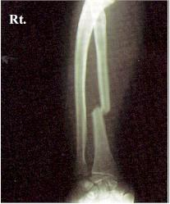
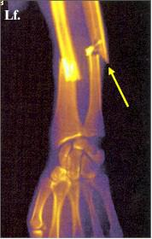

Open or Closed Fx? | Open or Closed Fx?
3. Lateral Thumb | 4. Shoulder
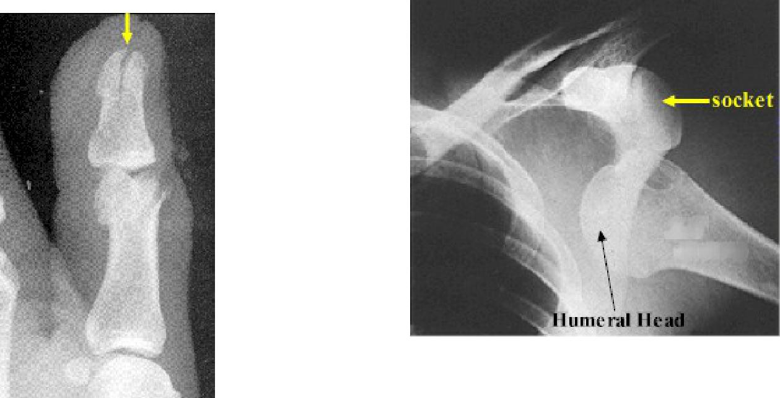

What’s wrong with this shoulder?

Type of fx?

5. AP & Lateral Wrist
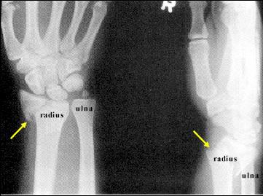

Type of fracture?

6. Lateral Elbow
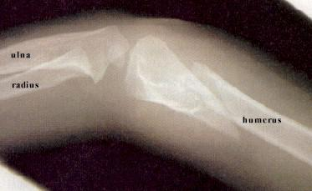

Type of fx?

7. Femur | 8. Skull
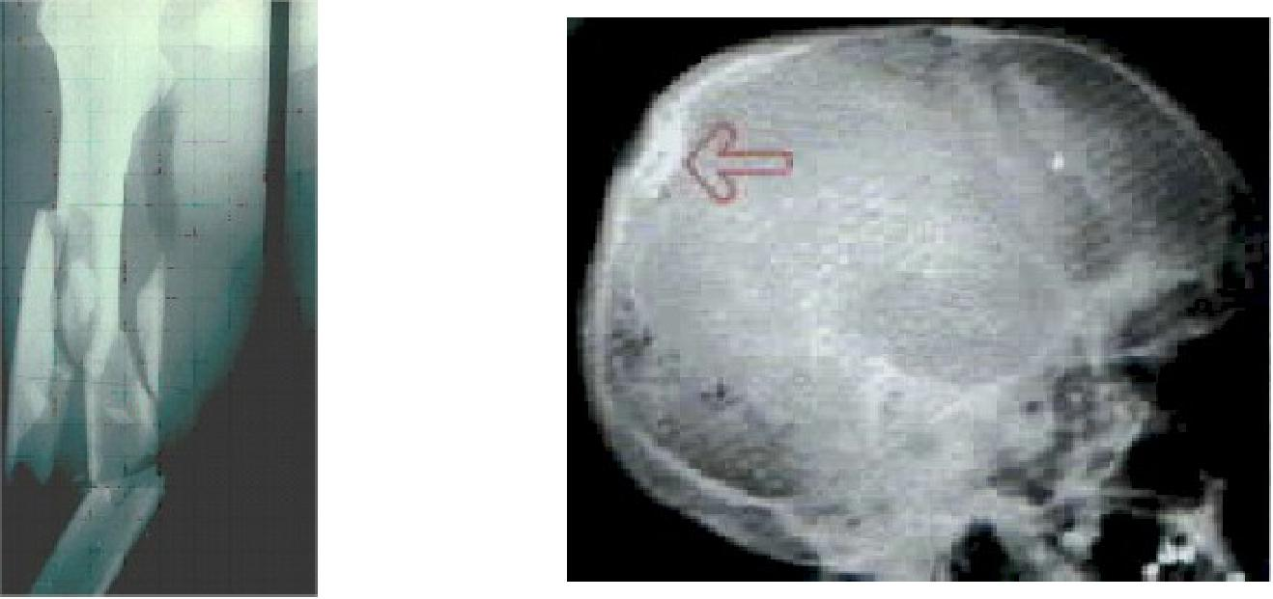

Type of fx? | Type of fx?

9. Lateral forearm-child
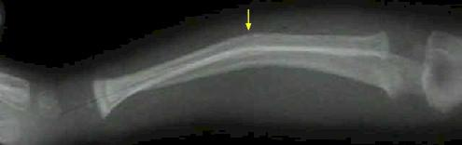

Type of fx?

10. | PA wrist | 11. | Lateral elbow
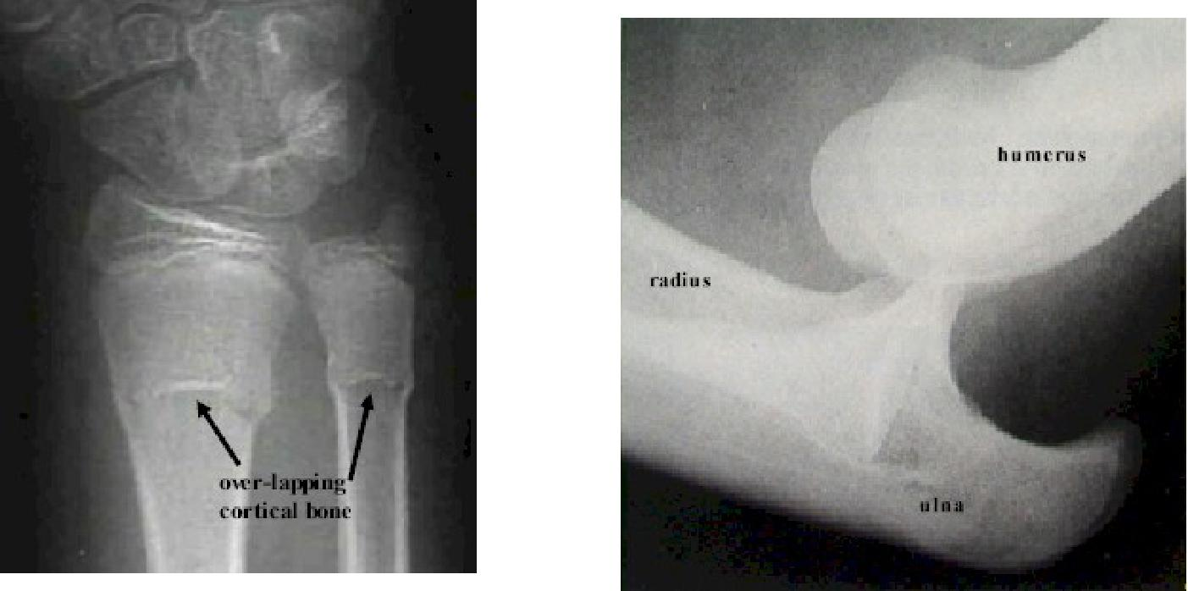

Type of fx? | Type of pathology?
12. AP tibia/fibula
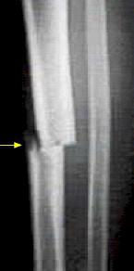

Type of fracture?

