HRM – Training and Development Case Study Analysis
Independent Practice Assignment #1 Rubric
Student Name: ____________________________________________________
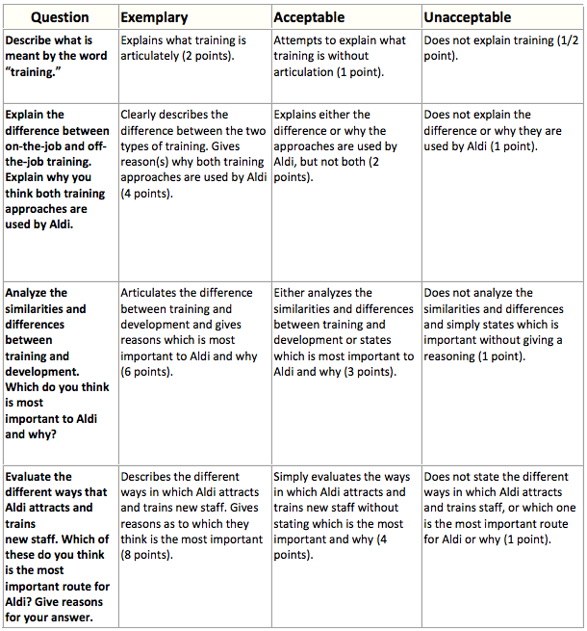
Total Score___________
Maximum 20 Points

