What is in your credit score?- KEY

Place each of the following components of a credit score next to a section of the pie chart that resembles how much it makes up your credit score.

Payment History Length of Credit History
Types of Credit Used Amounts Owed
New Credit
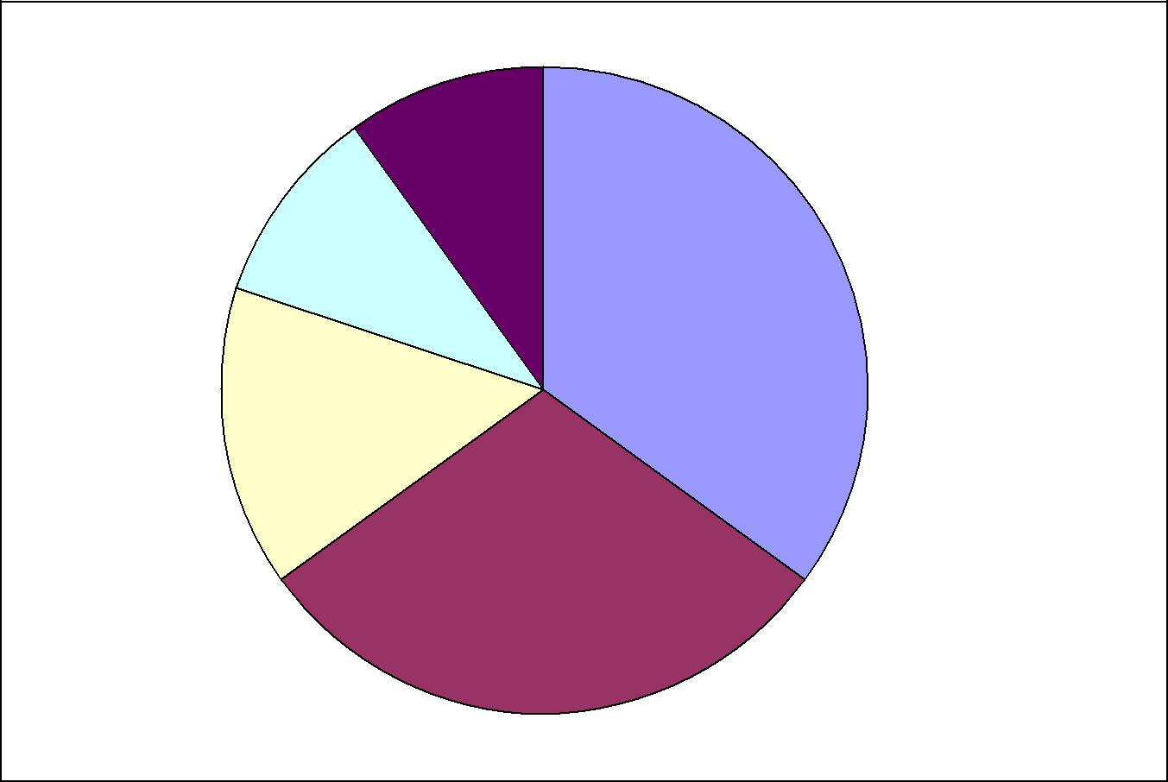

10% = Types of

Credit Used

10% = New Credit

35% = Payment

History

15% = Length of

Credit History

30% = Amounts

Owed

Source: Garman, E.T., & Forgue, R. (2007). Personal Finance (9th ed.). South-Western College.

