What is in your credit score?

Place each of the following components of a credit score next to a section of the pie chart that resembles how much it makes up your credit score.

Payment History Length of Credit History

Types of Credit Used Amounts Owed

New Credit
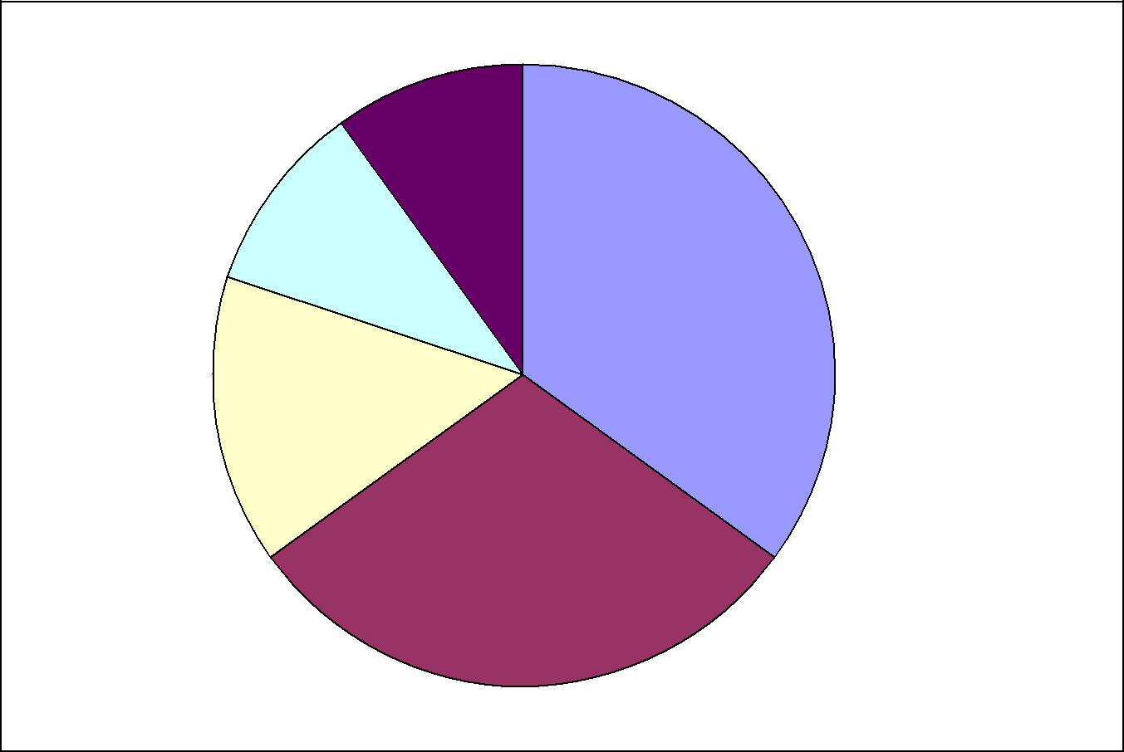

10%

10%

35%

15%

30%

Source: Garman, E.T., & Forgue, R. (2007). Personal Finance (9th ed.). South-Western College.

