Name:____________________________________ Date:_____________________________

Writing Rubric

 |  | 4 pts. | 3 pts. | 2 pts. Needs Some | 1 pt. Needs Much
 | Objectives |  |  |  |  | N/A |  | Pts.
 |  | Excellent | Good | Improvement | Improvement
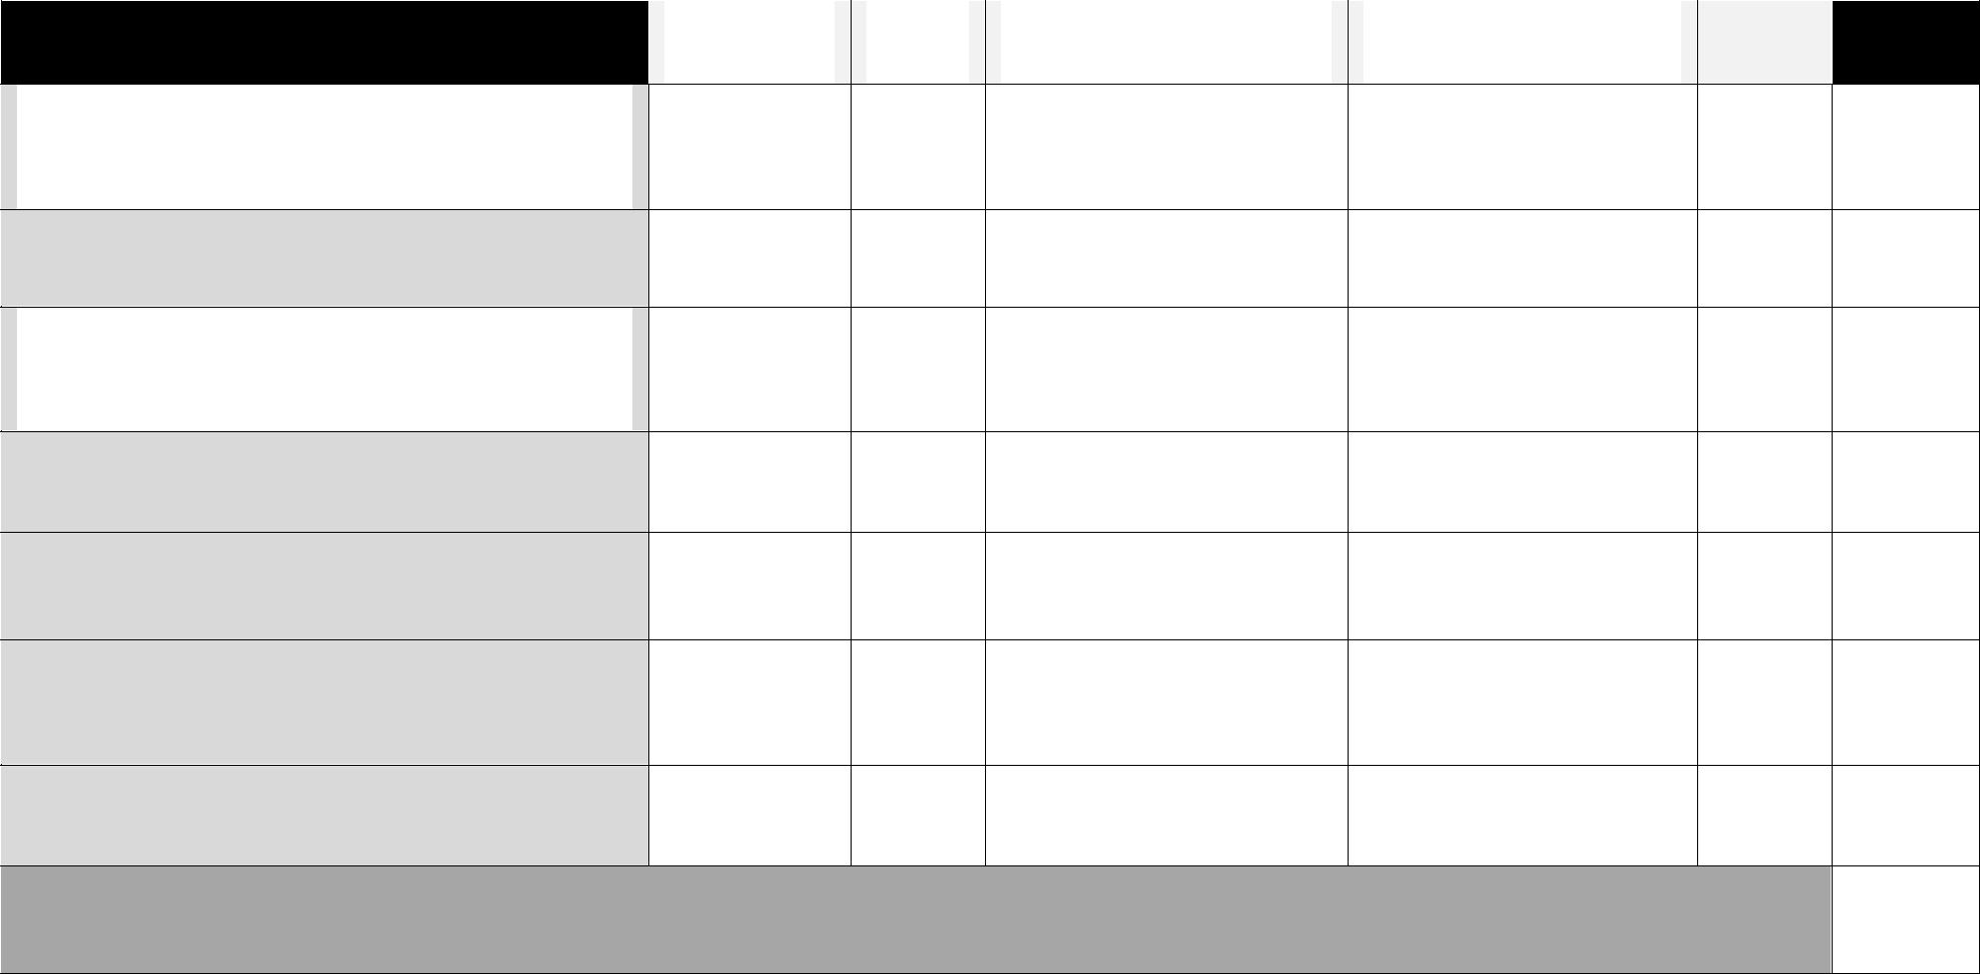
The writing has all required parts from
introduction to conclusion in smooth
transition.

The writing is interesting, supportive,
and complete.

The writing demonstrates that the
writer comprehends the writing
process.

Accurate spelling, grammar, and
punctuation

The content of paragraphs
emphasizes appropriate points.

The writer shows an understanding of
sentence structure, paragraphing, and
punctuation.

All sources and references are clearly
and accurately documented.

Total Points (28 pts.)

Comments:

